URL: https://adityabirlahospital.com/doctors/dentist-in-pune
Home / Doctors / Dental
Best Dentists in Pune
Dental health is a cornerstone of overall well-being, and at our hospital, we ensure that you receive exceptional care from experienced dental professionals. Our team of dentists in Pune specializes in everything from routine check-ups to advanced dental procedures, all delivered in a state-of-the-art environment.
Our Team of the Top Dentists in Pune
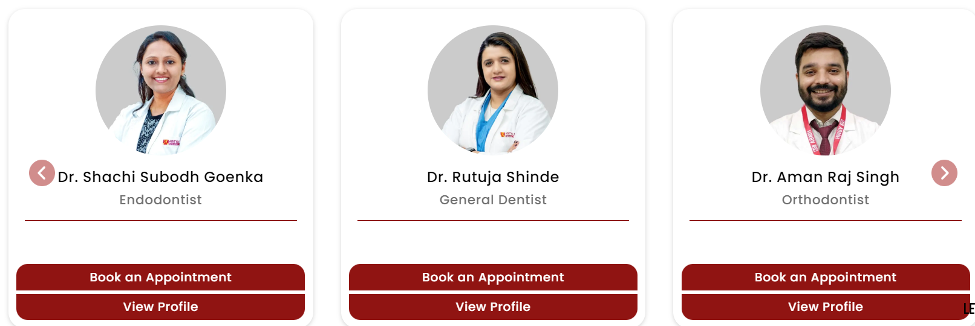
Our hospital is home to some of the best dentists in Pune, offering a comprehensive range of dental services tailored to meet your unique needs. Whether you’re looking for preventive care, cosmetic dentistry, or advanced dental treatments, our experts provide personalized solutions with a focus on your comfort and health.
What Our Dentists Specialise In:
How to Find the Top Dentists Near Me in Pune?
If you’re searching for top dentists in Pune, our hospital is your trusted destination for expert dental care. We understand that finding the right dentist is crucial, and our team is here to ensure a stress-free, high-quality experience every time.
Visit our hospital to access one of the most trusted dental teams in Pune, where your smile is our priority. Book your consultation today and take the first step toward achieving optimal dental health.

Nearby Locations:
Hinjewadi, Wakad, Baner, Aundh, Pimple Saudagar, Bhosari, Ravet, Chinchwad Gaon, Tathawade and Nigdi.
